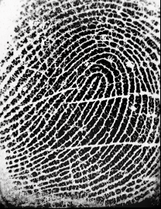
326/369/2017 | Registration No. :39M | 10:22 AM
Receipt
Village Name:  Aundh | Receipt No.:376 | Date: 06/03/2017
Document No.: HVL10/369/2017
Document Type :Leave and Licenses(36 A)
Presentor Name:Saujanya Satish Shetty
 | Registration Fee: | 1000.00
 | Total: | 1000.00
Leave and Licenses Agreement executed by presentor and Siddharth Gupta is received for registration.
 | Joint S.R. Haveli 10
Stamp duty of Rs.300/- is paid by GRN MH006281920201718E on 06/03/2017
Registration fee of Rs.1000/- is paid by GRN MH006281920201718E on 06/03/2017
Thumb Impression of Joint S.R. Haveli 10 :


Page 1 of 1 Joint S.R. Haveli 10

